Software Deployment Report

# Revision

Version 2

1/24/22 1:25 PM

# SME

Charles Wilson

# Abstract

This document describes the content of the software deployment report.

# Group / Owner

DevOps / Information Systems Security Developer

# Motivation

This document is motivated by the need to have formal processes in place tracking the software and configuration information deployed onto safety-critical, cyber-physical systems for certification of compliance to standards such as **ISO 21434** and **ISO 26262**.

# License

This work was created by **Motional** and is licensed under the **Creative Commons Attribution-Share Alike (CC BY-SA-4.0)** License.

[**https://creativecommons.org/licenses/by/4.0/legalcode**](https://creativecommons.org/licenses/by/4.0/legalcode)

# Overview

It is critical that all software and configuration information necessary to the operation of a product are archived and that a manifest of these materials is created. This serves to ensure that the product release can be updated should the need arise. It also provides a mechanism to allow for the quick determination of vulnerability for any of the elements used in the product’s creation. It can also serve as a baseline for determination of attempted alteration of the system.

# Process

The **Software Deployment Report** can be considered the same as or a subset of the **Payload Deployment Report** called out in the **Deployment Plan [4]**. The report is generated during the **Payload Deployment** activity (shown below).

# Report

There are three sections contained in the report:

* Summary
* Software manifest information
* Configuration information

## Summary

The summary section contains general information including, but not limited to:

* Deployment date
* Deployment package name
* Deployment package verification information (checksum, cryptographic hash, …)
* Deployment target device
* Deployment target device unique identifier

## Software Manifest Information

The software manifest is a list of uniquely identified software information showing the general composition of the deployed software.

**Note:** The preferred executable software information representation form is the Software Identification Tag format (**SWID**) **[2,3]**.

The software manifest is expected to contain a hierarchical representation of the software to be deployed to the system (or element). The scope of the manifest will be determined by whether the deployment is a full or incremental (update) one. The following shows the types of changes that the SWID encodes.

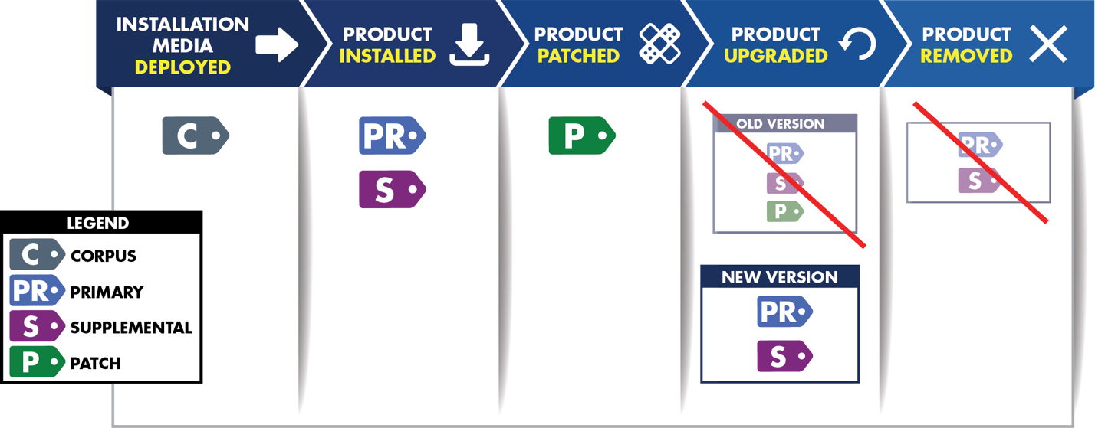

Figure - SWID Tags and the Software Lifecycle **[3]**

This section of the report is hierarchically structured mirroring the target.

It is not the intent of this document to reiterate the content and capabilities of **SWID**. For each software deployed, the information from the **<SoftwareIdentity>** tag should be included.

* Name
* Version
* Tag ID
* Patch event (update, remove, add)

**Note:** This list represents the minimum information required to uniquely identify the software being deployed. Additional information as may be helpful (previous version, entity, …)

## Configuration Information

The configuration information is a collection of the data used to configure the system’s software and hardware presented in human-readable form. There are numerous encoding formats for configuration file data. This process does not have a recommendation for a preferred encoding.

**Note:** Information in this section of the report is not intended to be derived from or conform to the SWID-based manifest.

The configuration information should be presented hierarchically (element, sub-system, setting). Information should include:

* Name
* Value
* Event (update, remove, add)

**Note:** This list represents the minimum information required. Additional information as may be helpful (previous value, …)

# References

1. **Archive Manifest** (AVCDL secondary document)
2. ISO 19770-2:2015 **Information technology - IT asset management - Part 2: Software identification tag**<https://www.iso.org/standard/65666.html>
3. NIST IR 8060 **Guidelines for the Creation of Interoperable Software Identification (SWID) Tags**  
   <https://nvlpubs.nist.gov/nistpubs/ir/2016/NIST.IR.8060.pdf>
4. **Deployment Plan** (AVCDL secondary document)